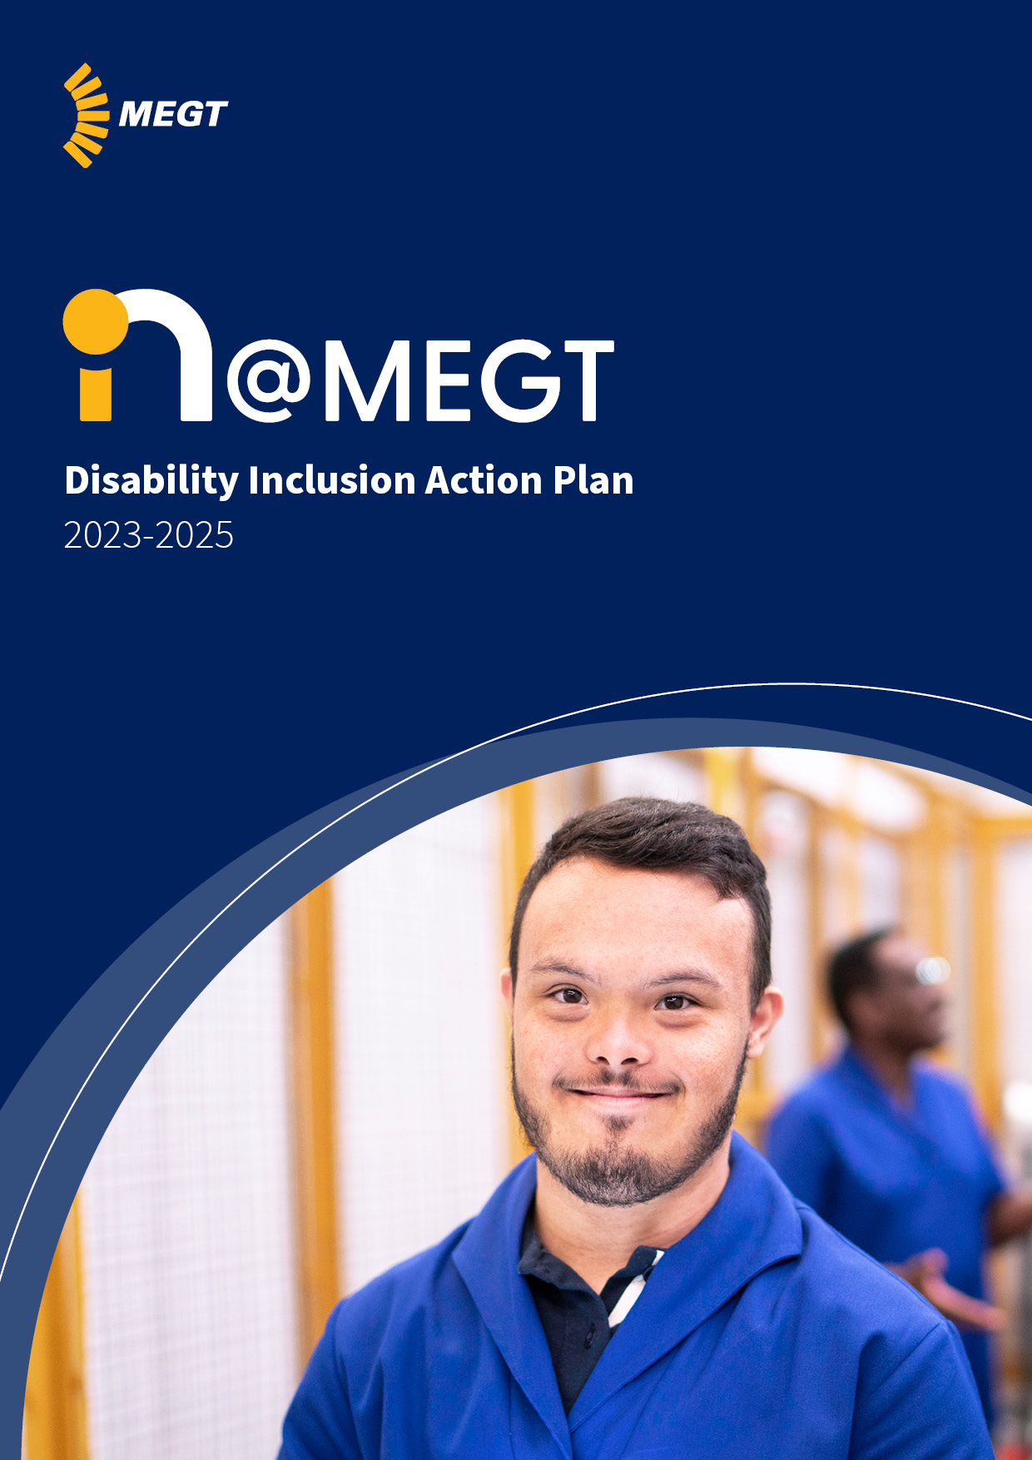
About this plan
MEGT is working in diverse communities nationally, as it has done for more than 40 years. The growth and ongoing commitment to be an inclusive employer of choice continues to be demonstrated in the Equal Opportunity and Diversity Policy (EODP) and Reconciliation Action Plan (RAP). MEGT has further shown its’ commitment by developing an inaugural Disability Inclusion and Action Plan (DIAP) 2023-2025, which identifies ways the business can support an inclusive and dignified approach to its’ clients, employees and customers living with disability.
This plan will support MEGT to strive for greater disability inclusion and achieve better participation outcomes for people living with disability. It’s the first step in our journey and we need to be willing to challenge our beliefs and mindsets in thinking about who is not seated at our table, and why.
This plan provides a roadmap to enhance employment and participation opportunities for our people and clients with disability across the communities that MEGT serves. It also highlights MEGT’s social responsibility for removing barriers, so that people living with disability can fully participate in all aspects of community life. There is overwhelming evidence to show the benefits of inclusion and retention of people with disability.
We acknowledge that not all disabilities are visible, and we will continue to focus on the importance of supporting the mental health and well-being of our people.
Our commitment to diversity and inclusion
MEGT’s philosophy is to ensure that nobody is left behind in terms of accessing the Australian workforce. Since 1982, we have understood the key values of diversity and inclusion are the cornerstones of a constructive, vibrant economy.
We appreciate what a variety of perspectives and lived experiences bring to our business. MEGT has been serving many in our community who have experienced significant barriers to achieving education and employment opportunities. We know that if we remove the barriers for people to employment, and if people are given every opportunity to access the workforce and are supported and included, they will be more engaged and productive. This is why accessibility and inclusion is at the forefront of our diversity agenda.
The actions contained within this Disability Inclusion Action Plan (DIAP) 2023-2025 are designed to build on the commitment to leave nobody behind. We will continue to be guided by our staff, community and the broader policy and legislative framework as we deliver on our actions.
It is our responsibility to ensure we have the systems and processes in place to encourage candidates living with disability to apply for roles within our business. We know, from working with thousands of employers right across Australia for more than 40 years, that to do so creates a ‘win-win’ scenario.
Hiring people living with disability means engaging with people that many workplace studies show are as reliable and productive as the average person in the workplace. Recognising this we need to do better in removing barriers that exist in our business for people with disability so they can participate in our workplace and have the supports available to reach their career potential.
We also need to ensure our policies and practice frameworks continue to evolve and put our people at the centre of all decisions including people with disability. We need to think about the language we use in the workplace, and the power of words to break down barriers for people with disability. Striving for accessibility with our physical places both in the built and online environments, must be priority for our whole MEGT community.
I encourage everyone to engage and create spaces for conversations to improve the opportunities and employment of people with disability across our business. By doing this, we are a step closer to achieving a more accessible and inclusive workplace that is representative of the community we serve.


Matthew Hick
Chief Executive Officer
MEGT (Australia) Ltd
About disability
The United Nations Convention on the Rights of Persons with Disabilities (CRPD) states: Persons with disabilities include those who have long-term physical, mental, intellectual or sensory impairments which in interaction with various barriers may hinder their full and effective participation in society on an equal basis with others. At MEGT, we believe that all people living with disability should have the same opportunities and dignified experiences as others in their communities, and therefore support the CRPD’s definition of disability.
In Australia, more than four million people are living with a disability, and at least 80% of those are non-visible (mental illness is one of the greatest causes of disability).
Australia is unique in that is has a rich history of First Nations communities and strong multi-cultural communities across all states and territories. A staggering 37% of Australia’s First Nations population 15 years and older have a reported physical disability or long-term health condition, and almost one million people living with a disability are from a non-English speaking background. This also supports the evidence of varied intersectionality across all minorities of people with disability and validates the importance of understanding and working towards delivering strong inclusion outcomes across the business.
It has been reported that 2.1 million Australians of working age live with disability, with an approximate unemployment rate of 10%. That equates to more than 200,000 people potentially looking for employment. From an employer perspective, we see these statistics as an opportunity and a resource waiting to be utilised to its fullest potential. From an employee lens, Australia experienced a mass employment movement in 2022 where employees’ values, beliefs and social responsibility began to be a key indicator for where people choose to work. Businesses which invest in inclusive and diverse workplaces have become a preferred choice to build a career.
Disability types
- Intellectual
- Physical
- Acquired brain injury
- Neurological
- Deadblind
- Developmental delay
- Vision
- Hearing
- Speech
- Psychiatric
Definition of disability
At MEGT, our goal is to ensure we create a workplace where everyone participates in all areas of employment and training without barriers.
There is no singular definition of disability and the definition applied in the legislation depends on the context in which disability is being considered. The legislative definition of disability is broad and may include circumstances that are not usually considered as disability.
The Disability Discrimination Act 1992 (Cth) defines disability as:
- total or partial loss of the person’s bodily or mental functions
- total or partial loss of a part of the body
- the presence in the body of organisms causing disease or illness
- the malfunction, malformation or disfigurement of a part of the person’s body
- a disorder or malfunction that results in the person learning differently from a person without the disorder or malfunction
- a disorder, illness or disease that affects a person’s thought processes, perception of reality, emotions or judgment, or that results in disturbed behaviour
And includes disability that:
- presently exists
- previously existed but no longer exists
- may exist in the future
At MEGT we know that disability is experienced in many ways. Our focus is on providing an inclusive culture and a workplace that considers the whole person and their experience with disability.
Key outcome areas of our DIAP (the four pillars of inclusion)
The four pillars of inclusion represent and raise several barriers that impact on a person with disability’s right to choice and control. Only by removing these barriers can we provide outcomes that are inclusive, dignified, and equitable. By doing so, we create better inclusion outcomes that benefit everyone.
Through the discovery and consultation process, we identified key actions that will support the four pillars of inclusion.
- Disability inclusive culture
- Accessible and inclusive workplaces
- Supporting access to meaningful employment
- Accessible systems and processes
Consultation
This Disability Inclusion Action Plan 2023-2025 was developed through a comprehensive discovery and consultation process with MEGT employees and leaders. It identified opportunities within the business and informed the actions to improve disability inclusion. The actions will help guide our decisions and inform our processes to ensure the services and facilities we provide are accessible to and appropriate for all people, including those with a disability, and can be achieved.
In October and November 2022, focus group sessions were held which invited people (including those living with a disability) to share their experiences with MEGT to inform the DIAP. These consultations co-led with Get Skilled Access created an opportunity to hear directly from the people in our business regarding their day-to-day experiences regarding disability inclusion and access. Feedback from these sessions about how MEGT can improve its’ disability inclusion outcomes and remove barriers to participation now inform the actions within this DIAP. We will continue to consult people with disability at each state of the plan thus ensuring it remains relevant and responsive to trends that emerge in this space.
Snapshot of consultation feedback
Across the desktop review and staff focus groups, key themes emerged. Aligned to the four pillars of inclusion, these included:
Disability inclusive culture
- Attitudinal barriers often exist. Unconscious bias and misconceptions often prevent us from understanding what people with disability can bring to a workplace. There is a strong desire to enhance awareness and knowledge for disability inclusion across MEGT
- During the desktop review we emphasised the importance of inclusive language within communications and content, as well as feeling represented within marketing material through authentic images
- There was strong support from all participants to better understand mental health disability more broadly, particularly post COVID-19
- Participants supported further opportunities to increase the visibility of the disability community and provide opportunities for community members to interact with people with disability to help shift attitudes and reduce stigma
Accessible and inclusive workplaces:
- It was communicated that MEGT’s head office is not accessible for people with disability, and there was strong support across all focus groups for exploring opportunities to consider accessibility for these premises, including the building itself and access to the building
- Staff were enthusiastic to learn how to make disability inclusion a part of their ‘regular’ workday. For example, they asked what steps are needed to ensure accessibility is considered for a meeting space, and the practical considerations to accomplish this successfully
Visible celebrations of people within the business and of MEGT clients living with a disability were highlighted during the focus groups. The opportunity to share stories helps to build a better understanding of why disability inclusion is so important in improving the emergency management planning for all MEGT locations to ensure vulnerable employees are considered during an emergency.
Supporting access to meaningful employment:
- Physical barriers exist within office spaces making it difficult for people with physical disability to navigate independently
- If a workplace adjustment is required, MEGT is proactive in supporting any requests. However, it was acknowledged that there is no formal process or education provided to staff on the provision of adjustments
- Opportunities exists to develop pathways to employment and leadership positions for people living with a disability within MEGT, and they should be considered and prioritised
- Improving the end-to-end recruitment process to ensure accessibility is considered across all parts of the recruitment process would improve the employment outcomes of people living with disability at MEGT
Accessible systems and processes
- It was identified that there were benefits from having a workplace adjustment policy and procedure which will improve the inclusion experience for people with a disability who are seeking employment
- Staff want to build on supports that assist them in the ‘how to’ regarding increased disability inclusion
- Procurement processes are being built to ensure MEGT is socially conscious when procuring products and services. It was clear the standard for procurement to align with MEGT’s Values is something the business takes very seriously
- An opportunity was identified to improve the accessibility of existing policies and IT (Information Technology) systems, including MEGT’s website and Intranet, and future procured services
Ongoing consultation, review, and monitoring
Key internal and external stakeholder consultations have informed the actions identified within our DIAP. The consultation identified day-to-day attitudinal barriers, various physical barriers across our community and those across the various systems and processes within the organisation. We also explored current trends and best practice outcomes in the areas of access and inclusion to benchmark this plan.
We sincerely thank our colleagues who participated in the consultation process, and for their ongoing support to improving accessibility and inclusion outcomes. We will continue to work with relevant staff and stakeholders to ensure the actions are delivered within the timeframes we have committed to.
Ongoing feedback from our staff, clients and community will be sought throughout the life of the plan and will help determine the success of the plan’s current and future actions.
MEGT will establish and develop a DIAP committee compositing representative of management, a Disability Engagement Manager and the people in the business including people living with disability.
Measurement of progress
Our DIAP’s success will be assessed against qualitative and quantitative measures, including:
- Actions successfully implemented over the life of the plan. Outputs and outcomes will be identified for each initiative to allow progress to be clearly measured
- Regularly engaging with staff who have been consulted and contributed to the development of the plan to seek feedback and inform the ongoing direction
- Operationally, MEGT will provide ongoing updates and progress on the actions of the DIAP to the Executive Team and the Office of the CEO. Achievements will be noted in the business’ Annual Report

